Project Planning Phase
Project Planning Template (Product Backlog, Sprint Planning, Stories, Story points)

Date | 1 November 2026
Team ID | EN25CS3010155
Project Name | Global Fuel Prices and Taxation Trends: A Comprehensive Global Performance Intelligence Report
Maximum Marks | 8 Marks

Product Backlog, Sprint Schedule, and Estimation (4 Marks)
Use the below template to create product backlog and sprint schedule
Sprint | Functional Requirement (Epic) | User Story Number | User Story / Task | Story Points | Priority | Team Members
Sprint-1 | Data Understanding & Connection | USN-1 | As a user, I can connect the global fuel prices CSV dataset to Tableau Public so that I can begin analyzing the data. | 5 | High | Ansh Sharma  (Individual)
Sprint-1 | Data Preparation | USN-2 | As a user, I can review field names, data types and relevant country, region and year fields so that the dataset is ready for visualization. | 5 | High | Ansh Sharma  (Individual)
Sprint-1 | KPI Analysis | USN-3 | As a user, I can view average petrol, diesel, LPG prices and average tax percentage in KPI cards. | 5 | High | Ansh Sharma  (Individual)
Sprint-1 | Country Maps | USN-4 | As a user, I can view petrol and diesel prices by country on maps to compare geographic differences. | 5 | High | Ansh Sharma  (Individual)
Sprint-2 | Yearly Fuel Trends | USN-5 | As a user, I can view yearly petrol price trends to understand changes over time. | 5 | High | Ansh Sharma  (Individual)
Sprint-2 | Yearly Fuel Trends | USN-6 | As a user, I can view yearly diesel and LPG price trends to compare their movement over time. | 5 | High | Ansh Sharma  (Individual)
Sprint-2 | Crude Oil Trend | USN-7 | As a user, I can view the yearly Brent crude trend alongside fuel-price trends. | 5 | Medium | Ansh Sharma  (Individual)
Sprint-2 | Dashboard Filters | USN-8 | As a user, I can use the available country and year filters to explore the displayed data. | 5 | Medium | Ansh Sharma  (Individual)
Sprint-3 | Regional Tax Analysis | USN-9 | As a user, I can compare average tax percentage across global regions using a pie chart. | 5 | High | Ansh Sharma  (Individual)
Sprint-3 | Country Tax Ranking | USN-10 | As a user, I can identify the five nations with the highest tax percentage using a ranked chart. | 5 | High | Ansh Sharma  (Individual)
Sprint-3 | Country Comparison | USN-11 | As a user, I can compare petrol, diesel and LPG prices for Canada, Mexico and the United States. | 5 | High | Ansh Sharma  (Individual)
Sprint-3 | Dashboard Assembly | USN-12 | As a user, I can view the key visualizations together in a structured Tableau dashboard. | 5 | High | Ansh Sharma  (Individual)
Sprint-4 | Tableau Story | USN-13 | As a user, I can navigate a seven-point Tableau Story that presents maps, trends, tax analysis, country comparison and conclusion. | 5 | High | Ansh Sharma  (Individual)
Sprint-4 | Presentation & Formatting | USN-14 | As a user, I can read clear chart titles, labels, legends and country names to understand each visualization. | 5 | Medium | Ansh Sharma  (Individual)
Sprint-4 | Validation | USN-15 | As a user, I can review the dashboard and story for correct aggregations, filters and consistent presentation. | 5 | High | Ansh Sharma  (Individual)
Sprint-4 | Publication | USN-16 | As a user, I can open the published Tableau Public Story through its shareable project link. | 5 | High | Ansh Sharma  (Individual)

Project Tracker, Velocity & Burndown Chart: (4 Marks)
Sprint | Total Story Points | Duration | Sprint Start Date | Sprint End Date (Planned) | Story Points Completed (as on Planned End Date) | Sprint Release Date (Actual)
Sprint-1 | 20 | 6 Days | 02 Nov 2026 | 07 Nov 2026 | Not yet recorded | Not yet recorded
Sprint-2 | 20 | 6 Days | 09 Nov 2026 | 14 Nov 2026 | Not yet recorded | Not yet recorded
Sprint-3 | 20 | 6 Days | 16 Nov 2026 | 21 Nov 2026 | Not yet recorded | Not yet recorded
Sprint-4 | 20 | 6 Days | 23 Nov 2026 | 28 Nov 2026 | Not yet recorded | Not yet recorded

Velocity:
Imagine we have a 10-day sprint duration, and the velocity of the team is 20 (points per sprint). Let’s calculate the team’s average velocity (AV) per iteration unit (story points per day)
For this project plan, the planned sprint capacity is 20 story points over 6 calendar days. Average planned velocity = 20 ÷ 6 = 3.33 story points per day. The completed points and actual release dates are left as 'Not yet recorded' because no actual sprint-tracking evidence was provided.


Burndown Chart:
A burn down chart is a graphical representation of work left to do versus time. It is often used in agile software development methodologies such as Scrum. However, burn down charts can be applied to any project containing measurable progress over time.
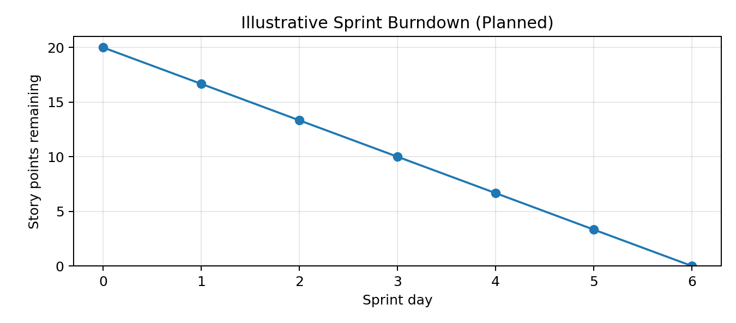
Note: This is an ideal planned burndown line; actual daily progress has not been supplied.

https://www.visual-paradigm.com/scrum/scrum-burndown-chart/
https://www.atlassian.com/agile/tutorials/burndown-charts

Reference:
https://www.atlassian.com/agile/project-management
https://www.atlassian.com/agile/tutorials/how-to-do-scrum-with-jira-software
https://www.atlassian.com/agile/tutorials/epics
https://www.atlassian.com/agile/tutorials/sprints
https://www.atlassian.com/agile/project-management/estimation
https://www.atlassian.com/agile/tutorials/burndown-charts

